DAILY ASSESSMENT FORMAT

|  |  |  |  |
| --- | --- | --- | --- |
| Date: | 30/07/2020 | Name: | Persis P |
| Course: | Coursera | USN: | 4AL17EC069 |
| Topic: | • Basic Statics | Semester & Section: | 6 & B |
| Github  Repository: |  |  |  |

SESSION DETAILS

Session images

Report:

Low statistical power:

Power

is the probability of correctly rejecting the

null hypothesis

when it is false (inverse of the

type II error rate). Experiments with low power have a higher probability of incorrectly accepting

the null hypothesis

—

that is

, committing a type II error and concluding that there is no effect when

there actually is (I.e. there is real covariation between the cause and effect). Low power occurs

when the sample size of the study is too small given other factors (small

effect sizes

, large group

variability, unreliable measures, etc.).

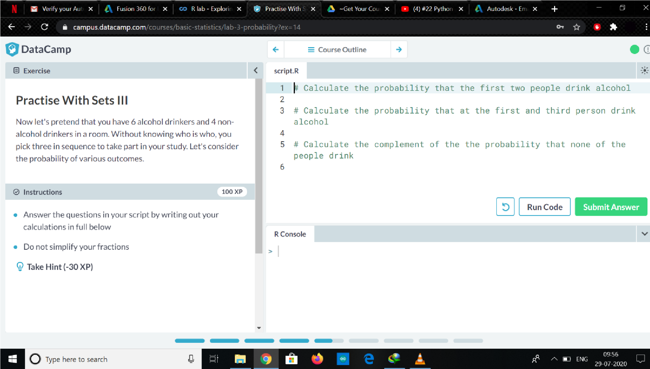

|  |
| --- |
| Violated assumptions of the test statistics:  Most statistical tests (particularly inferential statistics) involve assumptions about the data that make the analysis suitable for testing a hypothesis. Violating the assumptions of statistical tests can lead to incorrect inferences about the cause-effect relationship. The robustness of a test indicates how sensitive it is to violations. Violations of assumptions may make tests more or less likely to make type I or II errors.  Dredging and the error rate problem:  Each hypothesis test involves a set risk of a type I error (the alpha rate). If a researcher searches or "dredges" through their data, testing many different hypotheses to find a significant effect, they are inflating their type I error rate. The more the researcher repeatedly tests the data, the higher the chance of observing a type I error and making an incorrect inference about the existence of a relationship.  Unreliability of measures:  If the dependent and/or independent variable(s) are not measured reliably (i.e. with large amounts of measurement error), incorrect conclusions can be drawn. Restriction of range:  Restriction of range, such as floor and ceiling effects or selection effects, reduce the power of the experiment, and increase the chance of a type II error.[5] This is because correlations are attenuated (weakened) by reduced variability (see, for example, the equation for the Pearson product-moment correlation coefficient which uses score variance in its estimation). |
|  |
|  |